PRODUCT SPECIFICATION
PRODUCT NAME: Organic Virgin Coconut Oil
Revision date: 11.10.2023

PRODUCT DETAILS

Product | Organic Virgin Coconut Oil
Description | Organic Virgin Coconut Oil obtained by mechanical process, application of mild heat treatment not exceeding 60 ⁰C which purified by physical process of filtration.
Ingredient | Coconut Oil (Cocos nucifera oil)
Preservative | Not added
Intended Use | Organic Virgin Coconut oil is used for cooking, eating, dressings, frying and baking, direct consumption. Also it can be used in production of margarine, fat products and manufacturing of pastry.
Packing | Glass jar - 200 ml, 450 ml, 500 ml, 900 ml, 1000 ml; Plastic packaging – 300 ml, 3 l, 10 l, 20 l, 200 l; IBC tote with heating pad 1000 l - 915 kg.
Storage | Store in a cool, dry and odor free area with ambient temperature, out of direct sunlight. Thawing must be done only once. If the oil is reheated, the probability of caramelizing white to yellow sediments increases.
Shelf life | 24 months from date of manufacture.  Note: will solidify if stored below 79F (26 ⁰C), will liquefy if expose to above 79F (26 0C).
Country of origin | Sri Lanka

ORGANOLEPTIC PARAMETERS

Parameter | Test Method | Limits/Specification
Colour (1” cell) 5R+Y | AOCS Cc 13b-45 | Colourless/Clear liquid, free from visible foreign matters
Taste | Tasting | Free from rancid taste
Odor | Smelling | Characteristic

3. CHEMICAL, PHYSICAL & MICROBIOLOGICAL PARAMETERS

Chemical Parameters

Parameter | Test Method | Limits/Specification
Free Fatty Acid (as Lauric Acid) | LSTENISO 660:2009 (except 9,3 paragraph) | <0,2 % Max
Iodine Value | LSTENISO 3961:2013 | 5.5-10.6
Peroxide Value | LSTENISO 3960:2010 | < 3 meq/kg
Sulfite | 2014 V1.0AOAC 99.28 | No
Benzo[a] pyrene, µg/kg | SDP5.4.4.Ch.207:2015 | <0,2

Heavy metal

Parameter | Test Method | Limits/Specification
Arsenic (As) | LSTEN14084:2003 | 0.1 ppm Max
Lead (Pb) | LSTEN14084:2003 | 0.5 ppm Max
Mercury (Hg) | LSTEN14084:2003 | 0.1 ppm Max
Cadmium (Cd) | LSTEN14084:2003 | 0.5 ppm Max

Physical Parameters

Parameter | Test Method | Limits/Specification
Moisture | LSTENISO 662:2016 (except 9,3 paragraph) | <0,1 % Max
Relative density (40 ⁰C/water at 20 ⁰C) | - | 0.908 – 0.921

Microbiological Parameters

Parameter | Test Method | Limits/Specification
Aerobic Plate Count (CFU/g) | LSTENISO 4833-1:2013 | <1000
Total coliform (CFU/g) | LSTENISO 4831:2006 | <10
E. coli (CFU/g) | LSTENISO 7251:2005 | Absent
Yeast & Mold (CFU/g) | LSTENISO 21527-2:2008 | <1000
Salmonella (in 25 g) | LSTENISO 6579:2003 | Absent

Mycotoxins

Parameter | Test Method | Limits/Specification
Aflatoxin (B1 + B2 + G1 + G2) | cB 2000 by using HPLC | 0.06 ppb

Mineral Oil (MOSH, MOAH)

Parameter | Limits/Specification
MOSH (saturated, short  chain) C10-50 | < 13 mg/kg
MOAH (aromatic) C10-50 | < 2 mg/kg

- NUTRITION PROFILE

Typical Values
 | Per 100 g
Energy | 3757 kJ/898 kcal
Total Fat | 100 g
Saturated fat | 94 g
Trans Fatty Acids | < 1 g
Dietary Fibers | 0 g
Carbohydrate | 0 g
Sugars | 0 g
Protein | 0 g
Sodium | 0 g

- FATTY ACID PROFILE

Typical Value (per 100 g)
Medium Chain FA | Caproic Acid | C6 | 0 – 0.7
Medium Chain FA | Caprylic Acid | C8 | 4 – 10
Medium Chain FA | Capric Acid | C10 | 4 – 8
Medium Chain FA | Lauric Acid | C12 | 45 – 56
Long Chain FA | Myristic Acid | C14 | 16 – 21
Long Chain FA | Palmitic Acid | C16 | 7.5 – 10.2
Long Chain FA | Stearic Acid | C18:0 | 2 – 5
Long Chain FA | Oleic Acid | C18:1 | 5 – 10
Long Chain FA | Linoleic Acid | C18:2 | 1 – 2.5
Long Chain FA | Linolenic Acid | C18:3 | 0 – 0.2
 | Arachidic acid | C20:0 | 0 – 0.2
 | Eicosadienoic acid | C20:1 | 0 – 0.2

- ALLERGENS INFORMATION

Product | Present as ingredient |  | Present as ingredient
Cereals containing gluten:  Wheat  Rye  Barley  Oats  Spelled | No | Nuts:  Almonds  Hazelnuts  Cashew nuts  Pecans  Brazil Nuts  Pistachio nuts  Queensland nuts  Macadamia nuts | No
Kamut | No | Celery and derived products | No
Crustaceans and crustacean products | No | Mustard and derived products | No
Eggs and egg products | No | Sesame seeds and products made from sesame seeds | No
Fish and fish-based products | No | Sulfur dioxide and sulphites in concentrations higher than 10 mg / kg or 10 mg / l | No
Peanuts and peanut products | No | Lupins and lupine-based products | No
Soy and soy-based products | No | Molluscs | No
Milk and its derivatives (including lactose) | No
Yes = present No = absent T = Traces

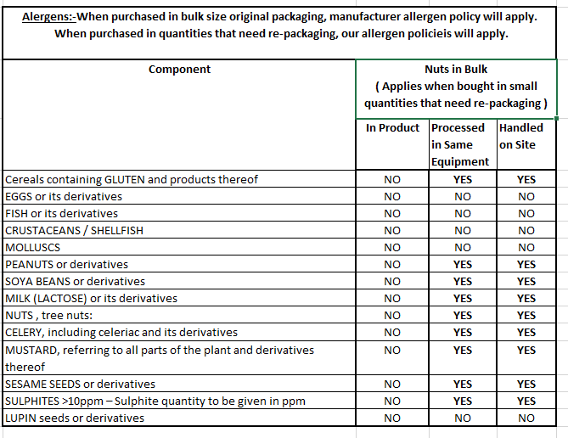

GMO declaration:
Does the product or components hereof, contain GM micro-organisms or is it produced with GM micro-organisms (incl. processing aids and additives): NO.

Note:
Chemical criteria: Heavy metals and Mycotoxins does not exceed the norms of the EU Regulation 2023/915 and amendments to this regulation. Pesticides does not exceed the norms of the EU regulation Nr. 396/2005.
Physical criteria: The product is filtered with a filter, which a mesh diameter is 1 mm.
Without allergens ir traces of allergens.
Usage: Suitable for anyone except babies.

